**Ecommerce: Order Creation and Fulfillment Flow**

Contents

1. Register as an Admin User 2

2. Login as an Admin User (Generate Token) 2

3. Add a Product 3

4. Register as a Normal User 3

5. Login as a Normal User (Generate Token) 4

6. Create a Cart 4

7. Add line items in a Cart 5

8. Create Order 5

9. Check Order Status 6

10. Check Notification in Console of Notification Service 6

## Register as an Admin User

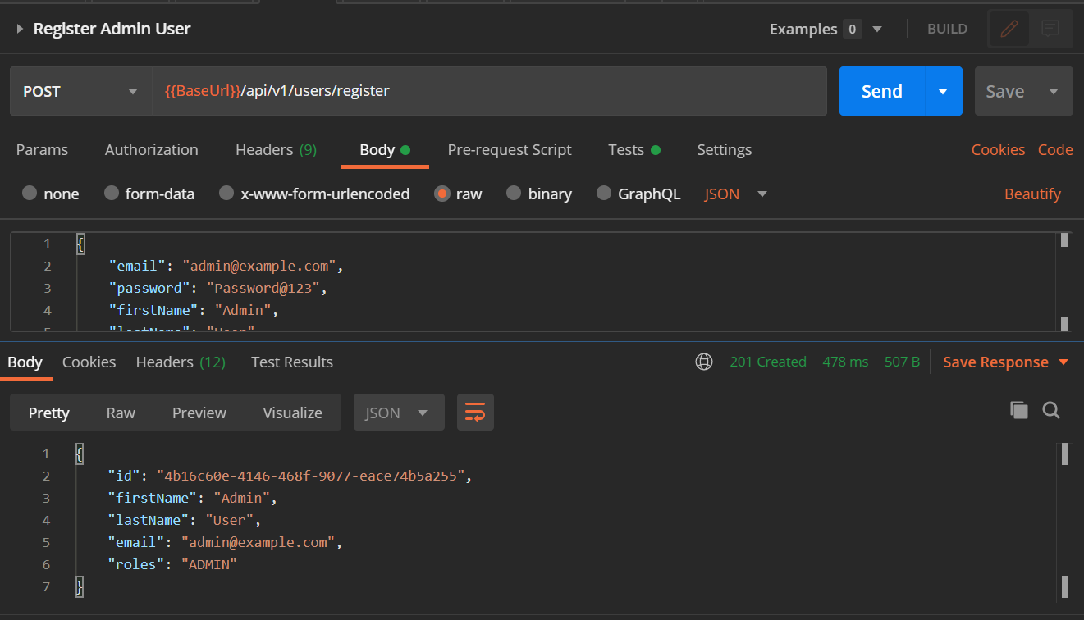

## Login as an Admin User (Generate Token)

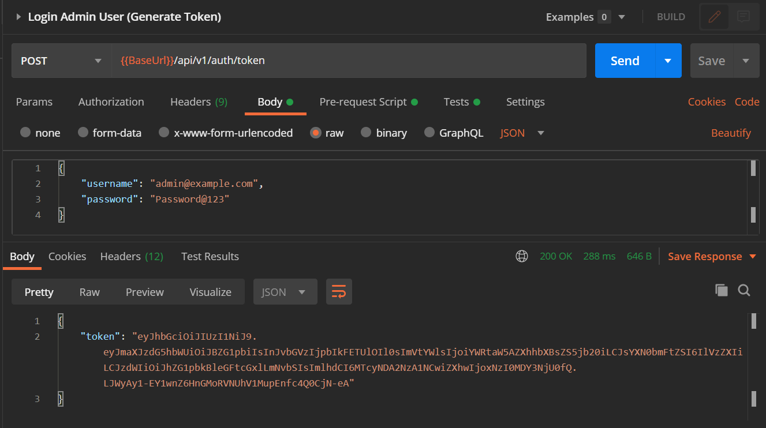

## Add a Product

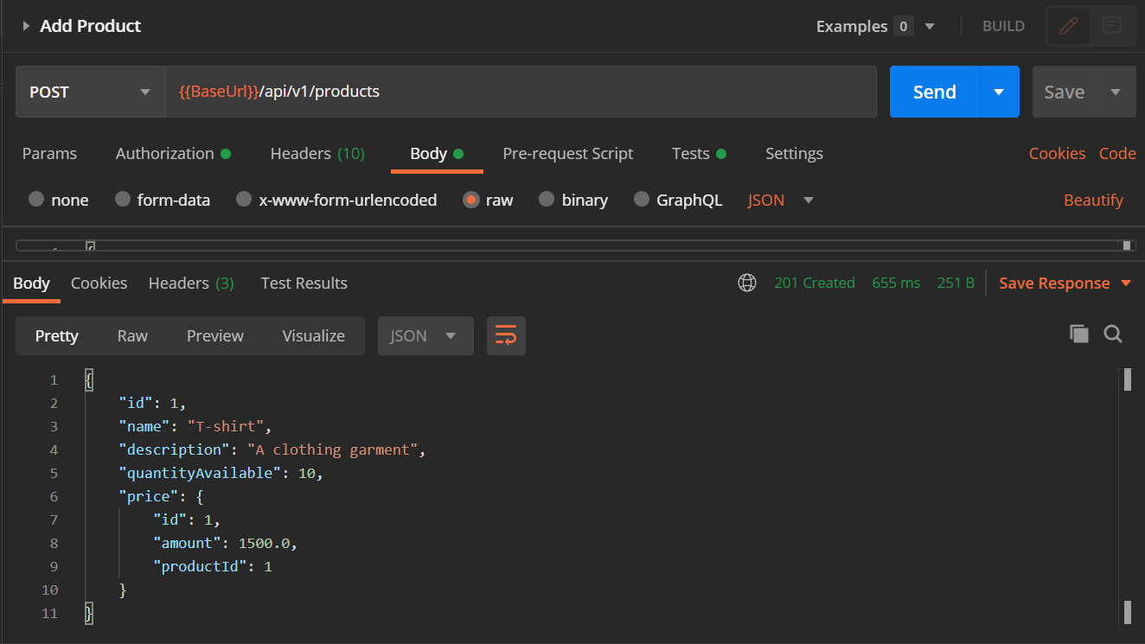

## Register as a Normal User

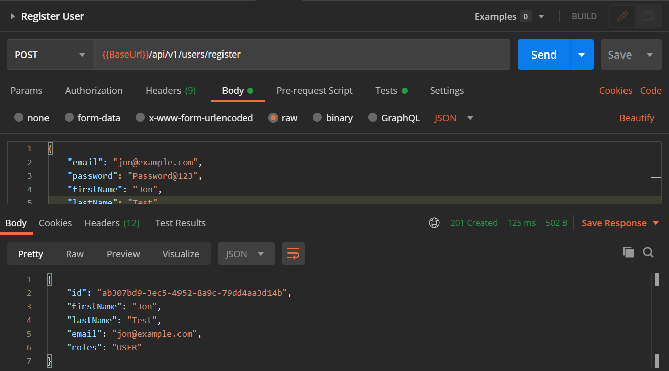

## Login as a Normal User (Generate Token)

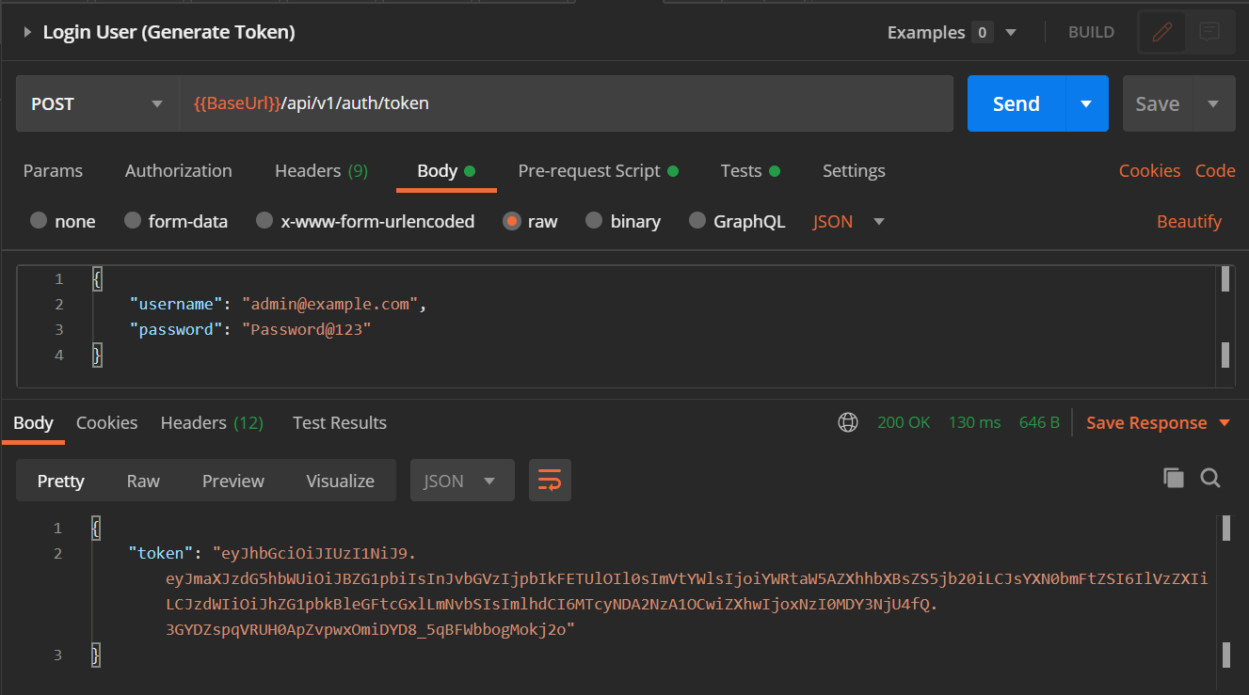

## Create a Cart

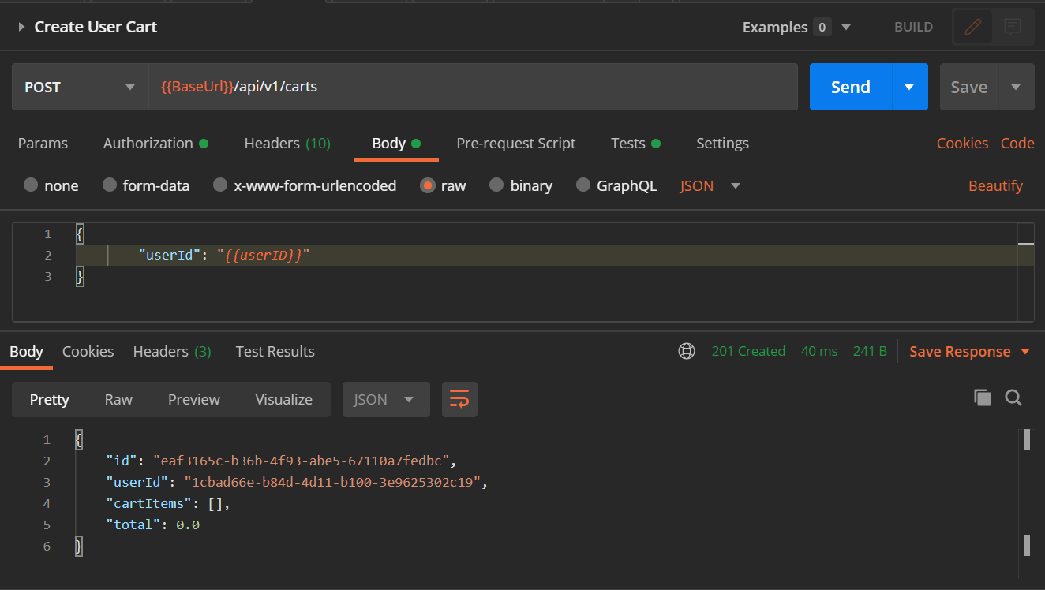

## Add line items in a Cart

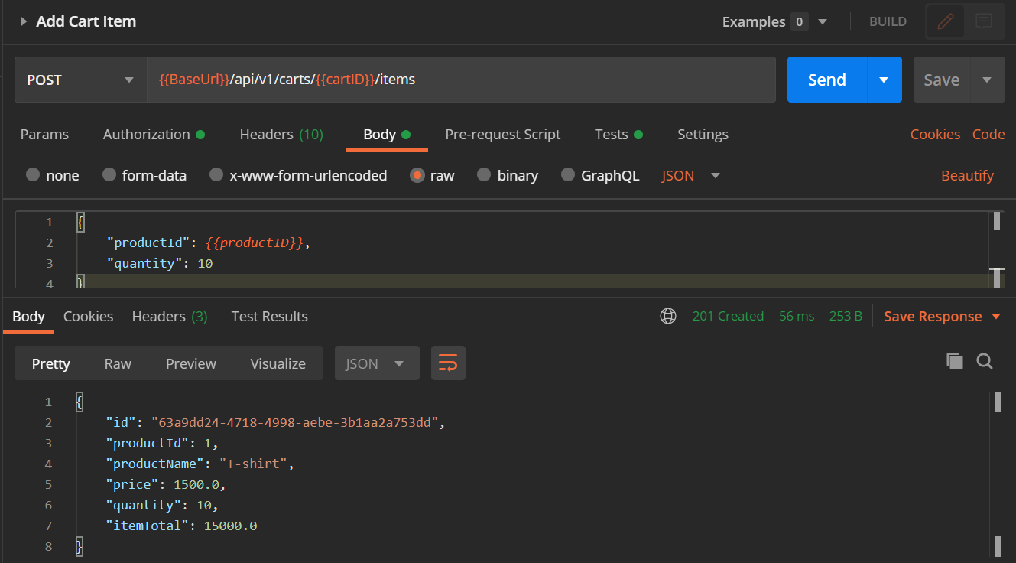

## Create Order

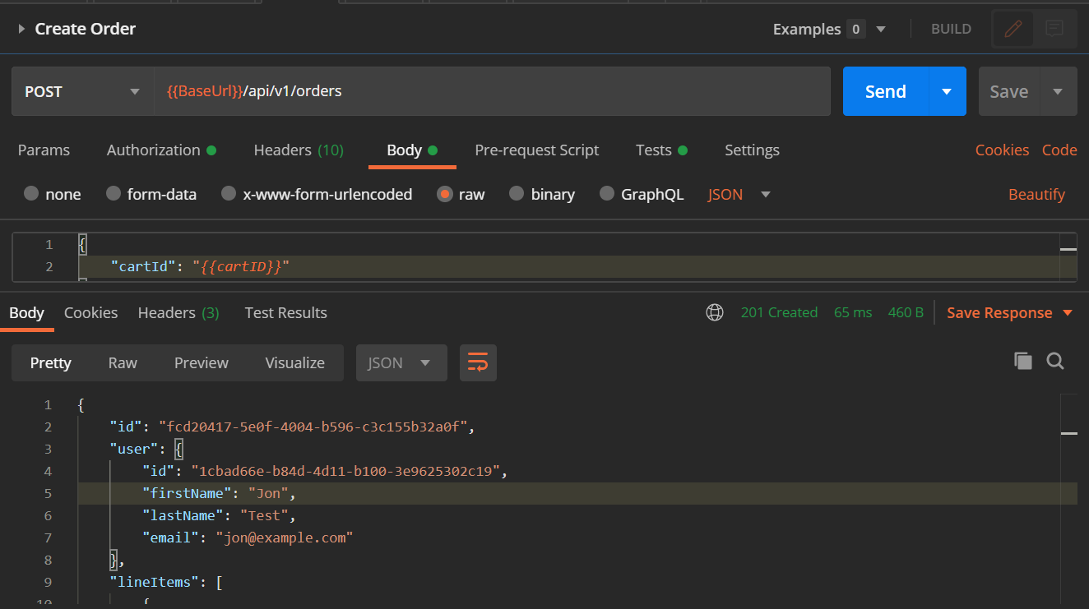

## Check Order Status

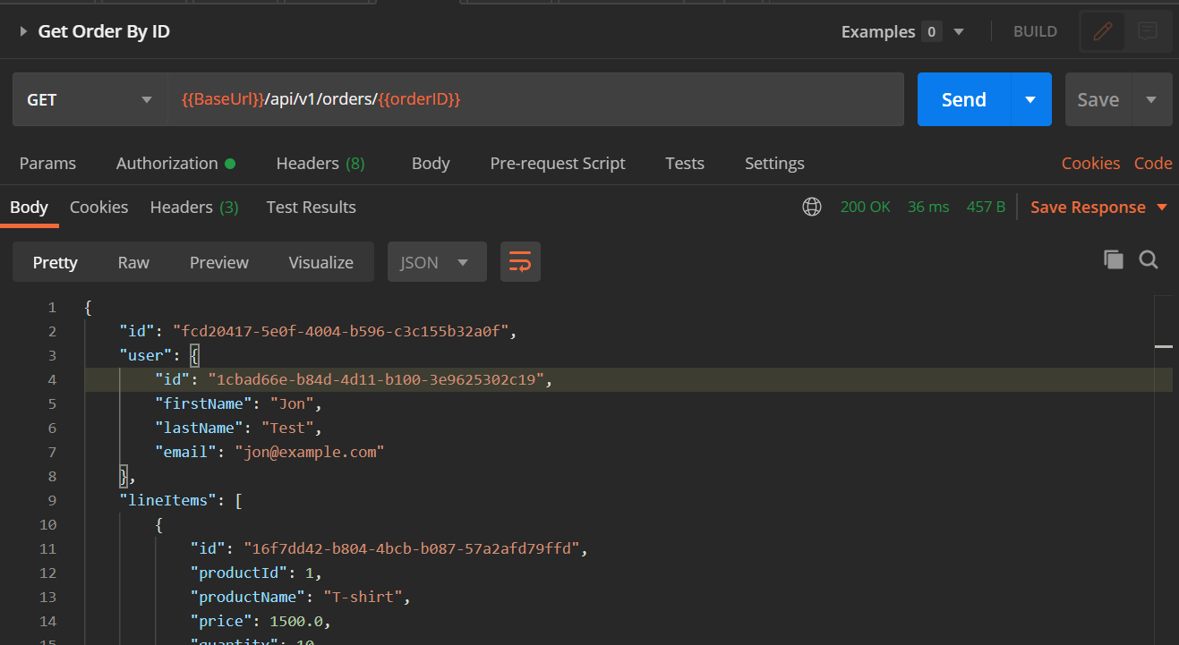

## Check Notification in Console of Notification Service